Justification for WDM Scoring of Concepts

**Concept A.1 - “Two Wheel Chariot” -** Net Score: 6.4

**Sherpas Required -** Score 7

* Requires one Sherpa, two wheels provide sufficient balance to negate the need for additional stabilization.

**Mechanical Efficiency from Rider -** Score 8

* Gross [mechanical efficiency of hand cycling](https://www.rug.nl/staff/l.h.v.van.der.woude/120420ursinathesis.pdf) is 6-15% (pg.13). The average

**Sales Cost -** Score 3

* Joellete (~$5300) plus [harness](https://www.canadiantire.ca/en/pdp/pro-armor-utv-4-point-harness-with-sewn-in-pads-3-in-0273619p.html#srp) (~$140) and cost of mechanical bike (~$1000) [Lukas’s personal experience], totalling to $6440

**Concept A.2 - “One Wheel Chariot”**  - Net Score: 5.0

**Sherpas Required -** Score 3

* Requires one Sherpa, one wheel requires greater sherpa input to maintain balance. For safety, a second sherpa would be required to maintain a reasonable safety margin.

**Mechanical Efficiency from Rider** - Score 8- Gross [mechanical efficiency of hand cycling](https://www.rug.nl/staff/l.h.v.van.der.woude/120420ursinathesis.pdf) can reach up to 15% (pg. 13), but can also be as low as 6%. The mechanical efficiency of a hand ergometer is ~20%

**Sales Cost -** Score 4

* Joellete (~$5300) plus harness (~$200) and cost of the bike with comparable mechanical components (~$1000) minus one wheel and set of bearings

**Concept B.1 - “Three Wheel Lever Chair”**  - Net Score: 8.0

**Sherpas Required -** Score 8

* The lever system allows adjustable torque input from the rider, which allows for more independence. Likely not full independence, so a score of 8 is given. Slightly higher than a ‘one-speed’ drive-system.

**Mechanical Efficiency from Rider -** Score 8

* Gross [mechanical efficiency of the lever](http://citeseerx.ist.psu.edu/viewdoc/download?doi=10.1.1.462.7986&rep=rep1&type=pdf) is ~3% higher than regular hand rim (pg. 769)
* Based on the chart below, it is ~11% at 40W input

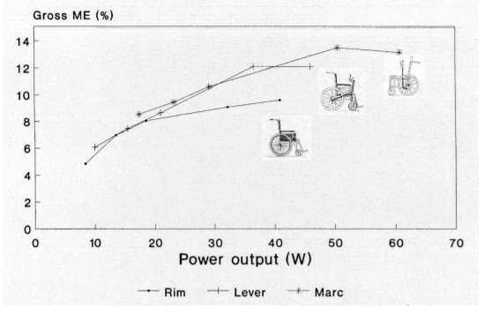

**Sales Cost -** Score 8

* Similar to the GRIT chair

**Concept B.2-“Three Wheel Hand-rim Chair” -** Net Score: 7.4

**Sherpas Required -** Score 7

* Lower mechanical efficiency may require a sherpa to assist.

**Mechanical Efficiency from Rider -** Score 6

* Gross mechanical efficiency of [hand-rim propulsion](https://www.rug.nl/staff/l.h.v.van.der.woude/120420ursinathesis.pdf) is 2-10% (pg.13). Use 8%, as the design would be aimed at optimizing ME (this also agrees with the chart above).

**Sales Cost -** Score 10

* Removing the lever drive propulsion system eliminates needing to license a patent, and removes the most complex mechanical elements. This would reasonably decrease the production cost

**Trail Rider -** Net Score: 1.7

**Sherpas Required -** Score 3

* With one wheel, the TrailRider is difficult to navigate and balance with one Sherpa. At least two Sherpas are necessary to ensure no tipping.

**Mechanical Efficiency from Rider -** Score 0

* No rider input at all.

**Sales Cost-** Score 2

* $7500, based on project documentation